eBGP Lab

Purpose

For this lab, our goal was to set up eBGP on a network while redistributing to OSPF and EIGRP. By doing this lab, we learned about how eBGP works and how to set it up on a network. The purpose was to get us to enable network connections between autonomous systems, and we did this successfully with BGP.

Background Information

Lab Summary

In this lab, we set up OSPF, EIGRP, and eBGP in between with IPv4 and IPv6. When we started this lab, the first step we took was to set up the PCs and each of the six router, with their respective IPv4 and IPv6 addresses. For OSPF, EIGRP, and eBGP, we started by setting up IPv4, testing to see if it works, and then setting up IPv6. We went and set up OSPF on Routers 1 and 2 in area 51, and Routers 5 and 6 in Area 2. After that, we set up EIGRP on Routers 3 and 4. We tested that EIGRP and OSPF worked properly, and then we set up eBGP between the OSPF and EIGRP networks. Next, we began setup on eBGP, where R2 was BGP 1, R3 was BGP 2, and R5 was BGP 3. After initially setting it up, we then added redistribution lines to OSPF, EIGRP, and BGP, so they could all communicate with each other. After we tested that everything could ping each other, we then repeated the entire process for IPv6, which only differed in setting up OSPF and EIGRP. After that was set up, we tested it again, and all the routers and PCs were able to ping each other.

Lab Commands

For this lab, we used many new commands to set up BGP, while using others that we already knew to set up the routers, OSPF, and EIGRP. We started by using the “ip address” and “ipv6 address” commands to set up the ip addresses on each interface, and then the “no shut” command to turn the interfaces on. After this, we used “router ospf 1” and “ipv6 router ospf 1” to set up OSPF, which were followed by “network” commands and setting up a router id with “router-id.” We then set up EIGRP with the command “router eigrp 100” and “ipv6 router eigrp 100,” and then its router id and networks with “eigrp router-id” and “network.” For IPv6 with OSPF and EIGRP, we made sure to add to each interface that needed it a “ipv6 router ospf 1” or “ipv6 eigrp 100” command. Next, we started with BGP by using “router bgp 1” on Router 2, “router bgp 2” on Router 3, and “router bgp 3” on Router 5. Next, we created a router id by using “bgp router-id” and then we used “neighbor … remote-as” to let the router know about the other routers’ addresses. We then set up an address family with “address-family ipv4” for IPv4 and “address-family ipv6” for IPv6. Under this, we added a network command “network” and we activated the neighbors with “neighbor … activate.” Next, we redistributed either OSPF or EIGRP depending on the router with “redistribute ospf” and “redistribute eigrp.” After this, we went into OSPF and EIGRP on the border routers of BGP and set up redistribution there with the “redistribute bgp” command. After setting up all these commands on the routers, we were able to get each area connected to each other with BGP and all the routers and PCs were able to ping each other.

Problems

Throughout this lab, we had many problems that prevented us from getting the lab completed and everything connected. First, we had problems was with setting up eBGP correctly. We had everything else set up, but nothing was able to get through the BGP area. After some troubleshooting, I was able to identify that we had accidentally set up each router with the same BGP number. It was an easy-to-miss mistake, and after we fixed it, it made it much easier to complete the lab.

Another problem we had was with OSPF for IPv6. We had fixed BGP, but one of the areas wasn’t able to connect through BGP. We started troubleshooting by pinging, tracerouting, looking at the ip routing tables, and by looking at the running config. After searching for a while, it turned out that one of network commands was missing. One of the routers was missing a “ipv6 ospf 1 area” command, and once we added that command, the lab was even closer to completion.

The final problem we had on the lab was a small and simple one. Everything was able to ping one another, except that PC2 could not ping PC1’s default gateway. We looked through Router 1’s running config, and we quickly spotted that the problem was a mistyped IPv6 address. R1’s IPv6 address towards PC1 was the same as PC’s, and it was causing problems. We fixed the issue by simply changing the IPv6 address, and then we had finished the lab because everything worked.

Conclusion

Overall, I learned a lot in this lab. Mainly, I learned how to set up eBGP on a network to connect multiple autonomous systems, such as OSPF and EIGRP. Along the way, we made multiple silly mistakes that ended up causing problems overall, such as a missing network statement and mistyping an IP address. Going through these silly mistakes and other problems hopefully helped us prepare for something similar when working on another lab in the future. Throughout the lab, we set up OSPF, EIGRP, and eBGP, and it helped us learn a lot about how BGP works and how it is used.

Network Diagram

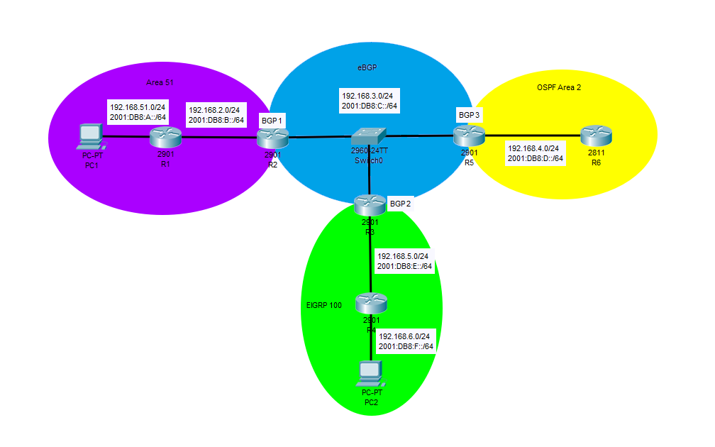

----------

R1

----------

Last configuration change at 23:15:47 UTC Fri Jan 17 2020

version 15.2

service timestamps debug datetime msec

service timestamps log datetime msec

no service password-encryption

hostname R1

boot-start-marker

boot-end-marker

no aaa new-model

memory-size iomem 10

ip cef

no ip domain lookup

ipv6 unicast-routing

ipv6 cef

multilink bundle-name authenticated

voice-card 0

license udi pid CISCO2901/K9 sn FTX1704Y038

license accept end user agreement

license boot module c2900 technology-package securityk9

license boot module c2900 technology-package uck9

vtp domain cisco

vtp mode transparent

redundancy

interface Embedded-Service-Engine0/0

no ip address

shutdown

interface GigabitEthernet0/0

ip address 192.168.51.2 255.255.255.0

duplex auto

speed auto

ipv6 address FE80::1 link-local

ipv6 address 2001:DB8:A::2/64

ipv6 ospf 1 area 51

interface GigabitEthernet0/1

ip address 192.168.2.1 255.255.255.0

duplex auto

speed auto

ipv6 address FE80::1 link-local

ipv6 address 2001:DB8:B::1/64

ipv6 ospf 1 area 51

interface Serial0/0/0

no ip address

shutdown

clock rate 2000000

interface Serial0/0/1

no ip address

shutdown

clock rate 2000000

router ospf 1

router-i 1.1.1.1

network 192.168.2.0 0.0.0.255 area 51

network 192.168.51.0 0.0.0.255 area 51

ip forward-protocol nd

no ip http server

no ip http secure-server

ipv6 router ospf 1

router-id 1.1.1.1

control-plane

mgcp profile default

gatekeeper

shutdown

line con 0

password cisco

login

line aux 0

line 2

no activation-character

no exec

transport preferred none

transport output pad telnet rlogin lapb-ta mop udptn v120 ssh

stopbits 1

line vty 0 4

login

transport input all

scheduler allocate 20000 1000

end

----------

R2

----------

Last configuration change at 22:59:34 UTC Fri Jan 17 2020

version 15.2

service timestamps debug datetime msec

service timestamps log datetime msec

no service password-encryption

hostname R2

boot-start-marker

boot-end-marker

no aaa new-model

memory-size iomem 10

ip cef

ipv6 unicast-routing

ipv6 cef

multilink bundle-name authenticated

voice-card 0

license udi pid CISCO2901/K9 sn FTX15208075

license accept end user agreement

license boot module c2900 technology-package securityk9

license boot module c2900 technology-package uck9

vtp domain cisco

vtp mode transparent

redundancy

interface Embedded-Service-Engine0/0

no ip address

shutdown

interface GigabitEthernet0/0

ip address 192.168.2.2 255.255.255.0

duplex auto

speed auto

ipv6 address FE80::2 link-local

ipv6 address 2001:DB8:B::2/64

ipv6 ospf 1 area 51

interface GigabitEthernet0/1

ip address 192.168.3.1 255.255.255.0

duplex auto

speed auto

ipv6 address FE80::2 link-local

ipv6 address 2001:DB8:C::1/64

ipv6 ospf 1 area 0

interface Serial0/0/0

no ip address

shutdown

clock rate 2000000

interface Serial0/0/1

no ip address

shutdown

clock rate 2000000

interface GigabitEthernet0/1/0

no ip address

shutdown

duplex auto

speed auto

router ospf 1

router-id 2.2.2.2

redistribute bgp 1 subnets

network 192.168.2.0 0.0.0.255 area 51

network 192.168.3.0 0.0.0.255 area 0

router bgp 1

bgp router-id 2.2.2.2

bgp log-neighbor-changes

neighbor 2001:DB8:C::5 remote-as 2

neighbor 2001:DB8:C::7 remote-as 3

neighbor 192.168.3.5 remote-as 2

neighbor 192.168.3.7 remote-as 3

address-family ipv4

network 192.168.3.0

redistribute ospf 1

neighbor 192.168.3.5 activate

neighbor 192.168.3.7 activate

exit-address-family

address-family ipv6

redistribute ospf 1

network 2001:DB8:C::/64

neighbor 2001:DB8:C::7 activate

neighbor 2001:DB8:C::5 activate

exit-address-family

ip forward-protocol nd

no ip http server

no ip http secure-server

ipv6 router ospf 1

router-id 2.2.2.2

redistribute bgp 1

control-plane

mgcp profile default

gatekeeper

shutdown

line con 0

line aux 0

line 2

no activation-character

no exec

transport preferred none

transport input all

transport output lat pad telnet rlogin lapb-ta mop udptn v120 ssh

stopbits 1

line vty 0 4

login

transport input all

scheduler allocate 20000 1000

end

----------

R3

----------

Last configuration change at 16:53:59 UTC Fri Jan 10 2003

version 15.2

service timestamps debug datetime msec

service timestamps log datetime msec

no service password-encryption

hostname R3

boot-start-marker

boot-end-marker

no aaa new-model

memory-size iomem 10

no ip domain lookup

ip cef

ipv6 unicast-routing

ipv6 cef

multilink bundle-name authenticated

voice-card 0

license udi pid CISCO2901/K9 sn FTX1520806V

license accept end user agreement

license boot module c2900 technology-package securityk9

license boot module c2900 technology-package uck9

vtp domain cisco

vtp mode transparent

redundancy

interface Embedded-Service-Engine0/0

no ip address

shutdown

interface GigabitEthernet0/0

ip address 192.168.5.4 255.255.255.0

duplex auto

speed auto

ipv6 address FE80::3 link-local

ipv6 address 2001:DB8:E::4/64

ipv6 eigrp 100

interface GigabitEthernet0/1

ip address 192.168.3.5 255.255.255.0

duplex auto

speed auto

ipv6 address FE80::3 link-local

ipv6 address 2001:DB8:C::5/64

ipv6 eigrp 100

interface Serial0/0/0

no ip address

shutdown

clock rate 2000000

interface Serial0/0/1

no ip address

shutdown

clock rate 2000000

interface GigabitEthernet0/1/0

no ip address

shutdown

duplex auto

speed auto

router eigrp 100

network 192.168.5.0

redistribute bgp 2 metric 100 1 255 1 1500

eigrp router-id 3.3.3.3

router bgp 2

bgp router-id 3.3.3.3

bgp log-neighbor-changes

neighbor 2001:DB8:C::1 remote-as 1

neighbor 2001:DB8:C::7 remote-as 3

neighbor 192.168.3.1 remote-as 1

neighbor 192.168.3.7 remote-as 3

address-family ipv4

network 192.168.3.0

redistribute eigrp 100

neighbor 192.168.3.1 activate

neighbor 192.168.3.7 activate

exit-address-family

address-family ipv6

redistribute eigrp 100

network 2001:DB8:C::/64

neighbor 2001:DB8:C::1 activate

neighbor 2001:DB8:C::7 activate

exit-address-family

ip forward-protocol nd

no ip http server

no ip http secure-server

ipv6 router eigrp 100

eigrp router-id 3.3.3.3

redistribute bgp 2 metric 100 1 255 1 1500

control-plane

mgcp profile default

gatekeeper

shutdown

line con 0

password cisco

login

line aux 0

line 2

no activation-character

no exec

transport preferred none

transport input all

transport output pad telnet rlogin lapb-ta mop udptn v120 ssh

stopbits 1

line vty 0 4

login

transport input all

scheduler allocate 20000 1000

end

----------

R4

----------

Last configuration change at 19:01:44 UTC Wed Jan 22 2020

version 15.2

service timestamps debug datetime msec

service timestamps log datetime msec

no service password-encryption

hostname R4

boot-start-marker

boot-end-marker

no aaa new-model

memory-size iomem 10

ip cef

no ip domain lookup

ipv6 unicast-routing

ipv6 cef

multilink bundle-name authenticated

voice-card 0

license udi pid CISCO2901/K9 sn FTX180180ME

license accept end user agreement

license boot module c2900 technology-package securityk9

license boot module c2900 technology-package uck9

vtp domain cisco

vtp mode transparent

redundancy

interface Embedded-Service-Engine0/0

no ip address

shutdown

interface GigabitEthernet0/0

ip address 192.168.6.2 255.255.255.0

duplex auto

speed auto

ipv6 address FE80::4 link-local

ipv6 address 2001:DB8:F::2/64

ipv6 eigrp 100

interface GigabitEthernet0/1

ip address 192.168.5.3 255.255.255.0

duplex auto

speed auto

ipv6 address FE80::4 link-local

ipv6 address 2001:DB8:E::3/64

ipv6 eigrp 100

interface Serial0/0/0

no ip address

shutdown

clock rate 2000000

interface Serial0/0/1

no ip address

shutdown

clock rate 2000000

interface GigabitEthernet0/1/0

no ip address

shutdown

duplex auto

speed auto

router eigrp 100

network 192.168.5.0

network 192.168.6.0

eigrp router-id 4.4.4.4

ip forward-protocol nd

no ip http server

no ip http secure-server

ipv6 router eigrp 100

eigrp router-id 4.4.4.4

control-plane

mgcp profile default

gatekeeper

shutdown

line con 0

login

line aux 0

line 2

no activation-character

no exec

transport preferred none

transport input all

transport output pad telnet rlogin lapb-ta mop udptn v120 ssh

stopbits 1

line vty 0 4

login

transport input all

scheduler allocate 20000 1000

end

----------

R5

----------

Last configuration change at 19:44:17 UTC Wed Jan 22 2020

version 15.2

service timestamps debug datetime msec

service timestamps log datetime msec

no service password-encryption

hostname R5

boot-start-marker

boot-end-marker

no aaa new-model

memory-size iomem 10

ip cef

ipv6 unicast-routing

ipv6 cef

multilink bundle-name authenticated

voice-card 0

license udi pid CISCO2901/K9 sn FTX180180MA

license accept end user agreement

license boot module c2900 technology-package securityk9

license boot module c2900 technology-package uck9

vtp domain cisco

vtp mode transparent

redundancy

interface Embedded-Service-Engine0/0

no ip address

shutdown

interface GigabitEthernet0/0

ip address 192.168.3.7 255.255.255.0

duplex auto

speed auto

ipv6 address FE80::5 link-local

ipv6 address 2001:DB8:C::7/64

ipv6 ospf 1 area 0

interface GigabitEthernet0/1

ip address 192.168.4.4 255.255.255.0

duplex auto

speed auto

ipv6 address FE80::5 link-local

ipv6 address 2001:DB8:D::4/64

ipv6 ospf 1 area 2

interface Serial0/0/0

no ip address

shutdown

clock rate 2000000

interface Serial0/0/1

no ip address

shutdown

clock rate 2000000

router ospf 1

router-id 5.5.5.5

redistribute bgp 3 subnets

network 192.168.3.0 0.0.0.255 area 0

network 192.168.4.0 0.0.0.255 area 2

router bgp 3

bgp router-id 5.5.5.5

bgp log-neighbor-changes

neighbor 2001:DB8:C::1 remote-as 1

neighbor 2001:DB8:C::5 remote-as 2

neighbor 192.168.3.1 remote-as 1

neighbor 192.168.3.5 remote-as 2

address-family ipv4

network 192.168.3.0

redistribute ospf 1

no neighbor 2001:DB8:C::1 activate

no neighbor 2001:DB8:C::5 activate

neighbor 192.168.3.1 activate

neighbor 192.168.3.5 activate

exit-address-family

address-family ipv6

redistribute ospf 1

network 2001:DB8:C::/64

neighbor 2001:DB8:C::1 activate

neighbor 2001:DB8:C::5 activate

exit-address-family

ip forward-protocol nd

no ip http server

no ip http secure-server

ipv6 router ospf 1

router-id 5.5.5.5

redistribute bgp 3

control-plane

mgcp profile default

gatekeeper

shutdown

line con 0

line aux 0

line 2

no activation-character

no exec

transport preferred none

transport output lat pad telnet rlogin lapb-ta mop udptn v120 ssh

stopbits 1

line vty 0 4

login

transport input all

scheduler allocate 20000 1000

end

----------

R6

----------

version 12.4

service timestamps debug datetime msec

service timestamps log datetime msec

no service password-encryption

hostname R6

boot-start-marker

boot-end-marker

logging message-counter syslog

no aaa new-model

memory-size iomem 10

dot11 syslog

ip source-route

ip cef

no ipv6 cef

multilink bundle-name authenticated

ipv6 unicast-routing

voice-card 0

vtp domain cisco

vtp mode transparent

archive

log config

hidekeys

interface FastEthernet0/0

ip address 192.168.4.3 255.255.255.0

duplex auto

speed auto

ipv6 address 2001:DB8:D::3/64

ipv6 ospf 1 area 2

interface FastEthernet0/1

no ip address

shutdown

duplex auto

speed auto

interface Serial0/0/0

no ip address

shutdown

no fair-queue

clock rate 2000000

interface Serial0/0/1

no ip address

shutdown

clock rate 2000000

router ospf 1

router-id 6.6.6.6

log-adjacency-changes

network 192.168.4.0 0.0.0.255 area 2

ip forward-protocol nd

no ip http server

no ip http secure-server

ipv6 router ospf 1

router-id 6.6.6.6

control-plane

mgcp fax t38 ecm

mgcp behavior g729-variants static-pt

line con 0

line aux 0

line vty 0 4

login

scheduler allocate 20000 1000

end

--------------------------------

Pings and Traceroute: PC2 -> PC1

--------------------------------

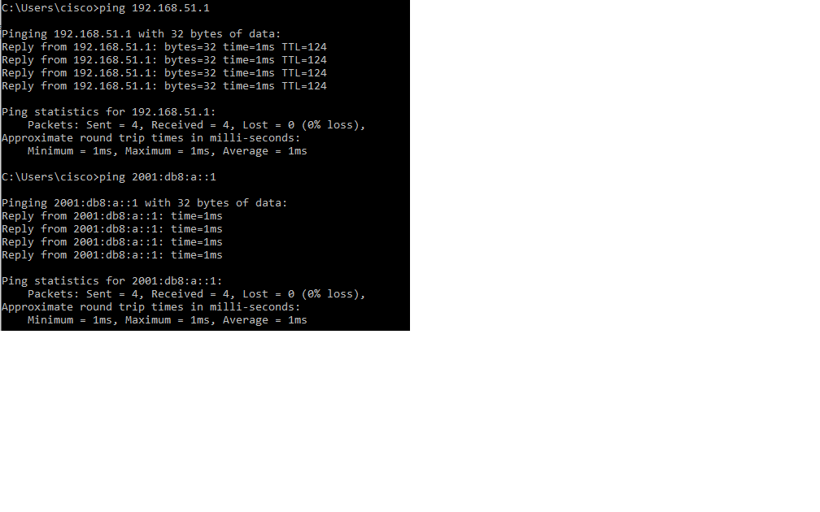

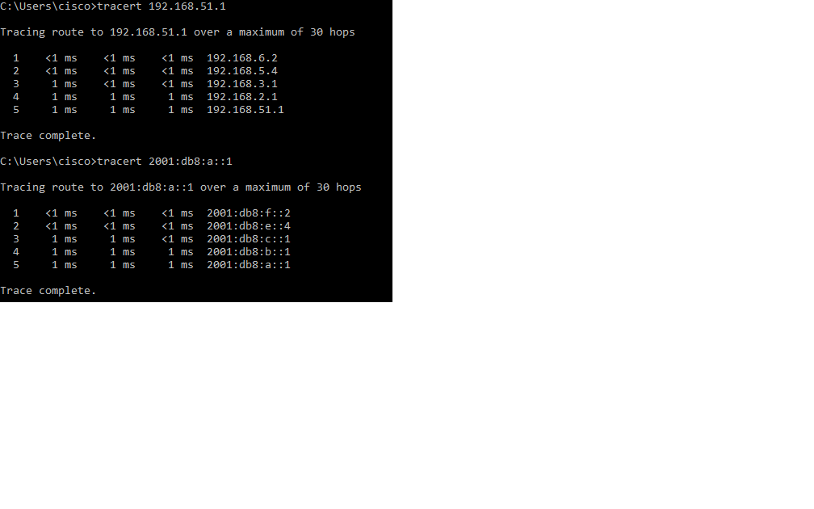

--------------------------------

Pings and Traceroute: PC2 -> R6

--------------------------------

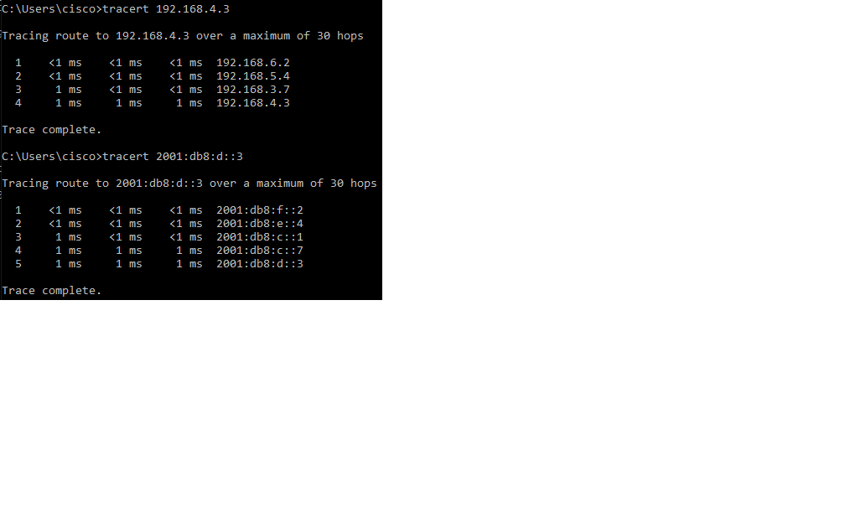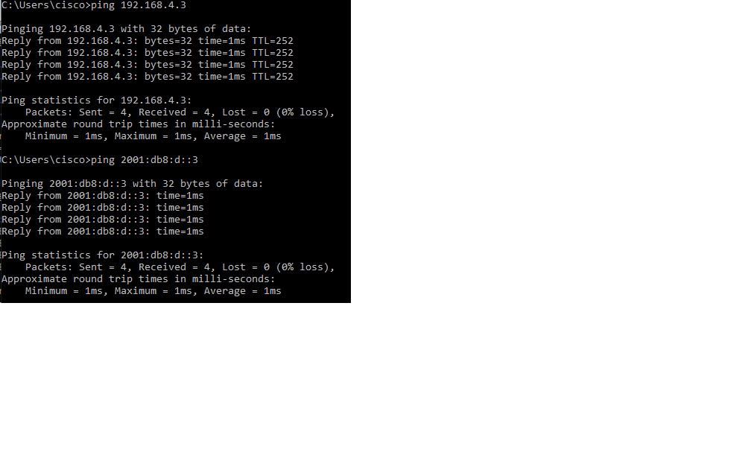

--------------------------------

Pings and Traceroute: PC1 -> PC2

--------------------------------

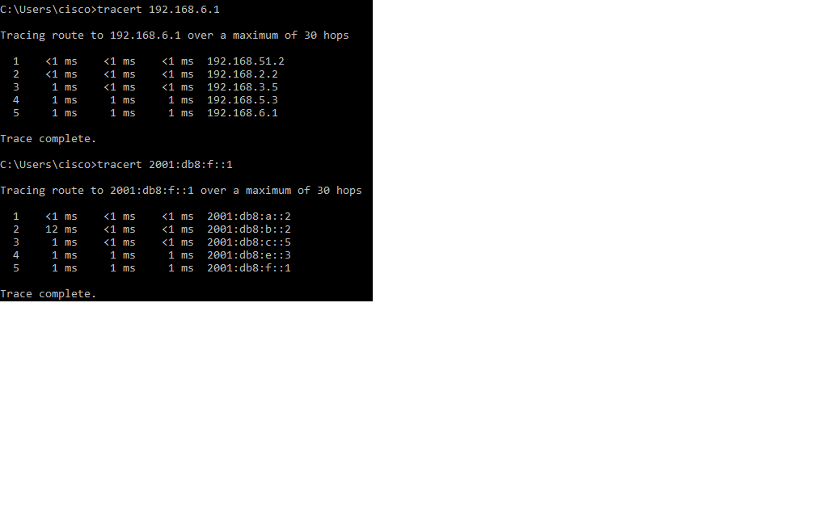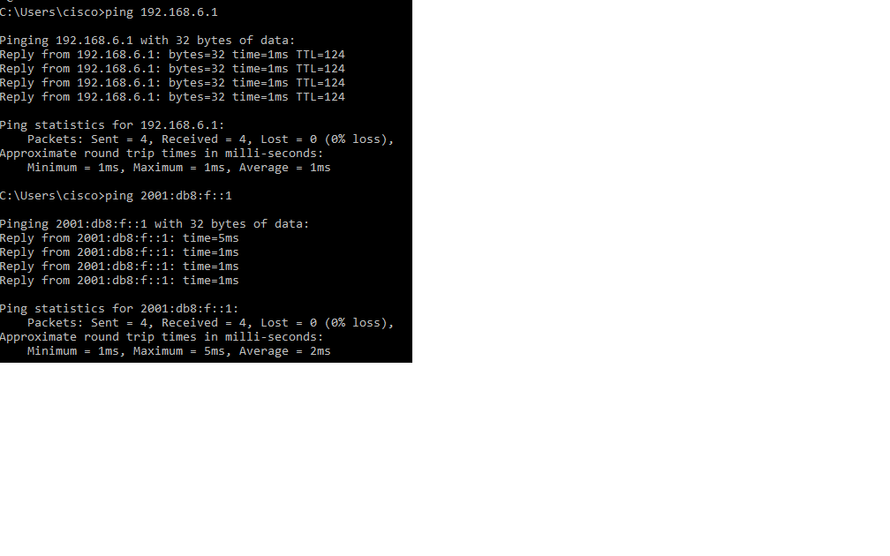

--------------------------------

Pings and Traceroute: PC1 -> R6

--------------------------------

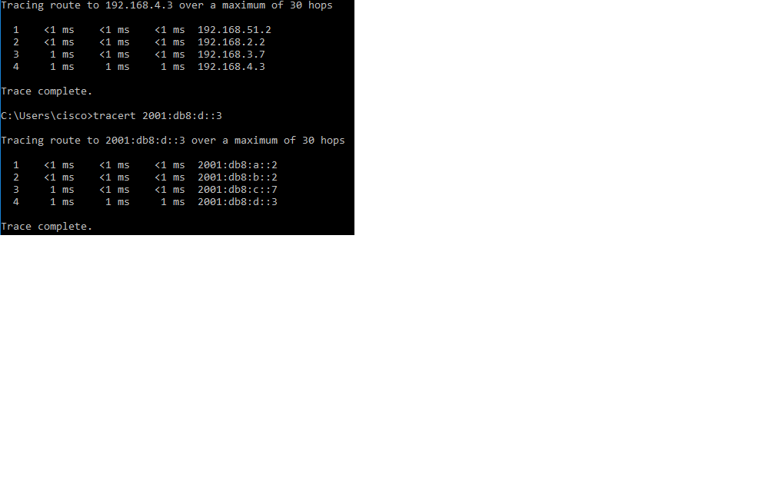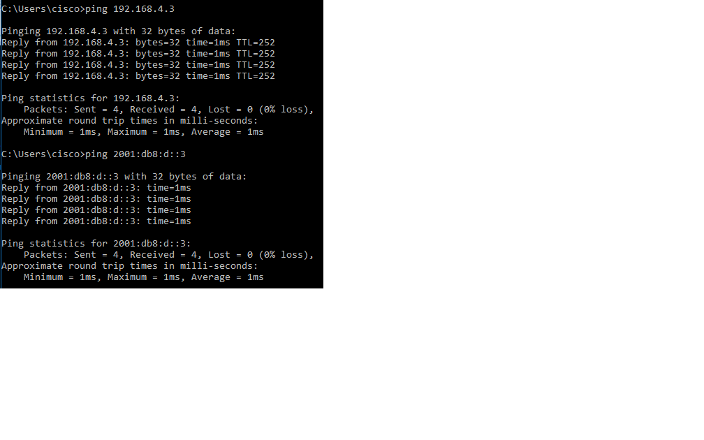

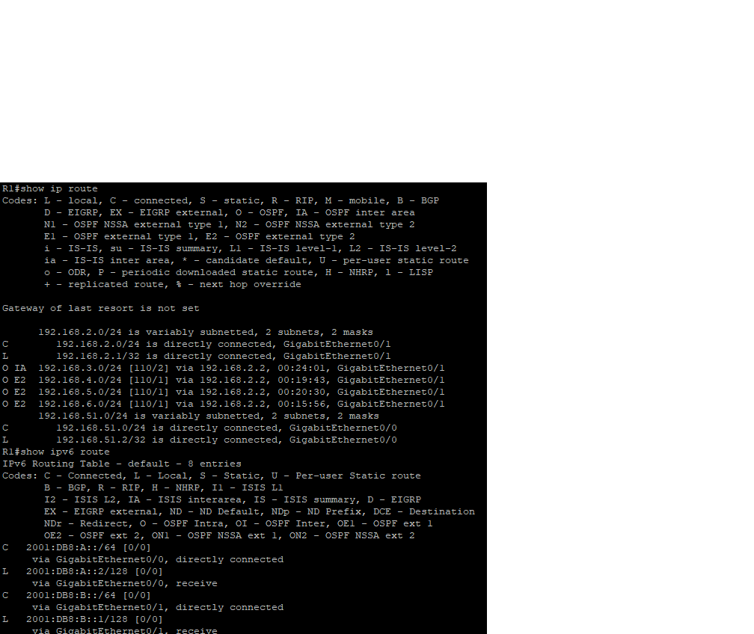----------------

Routing Table R1

----------------

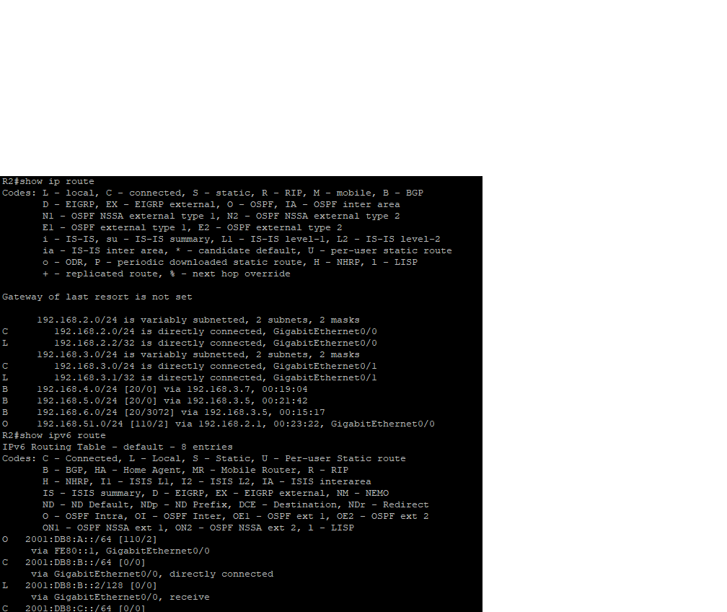----------------

Routing Table R2

----------------

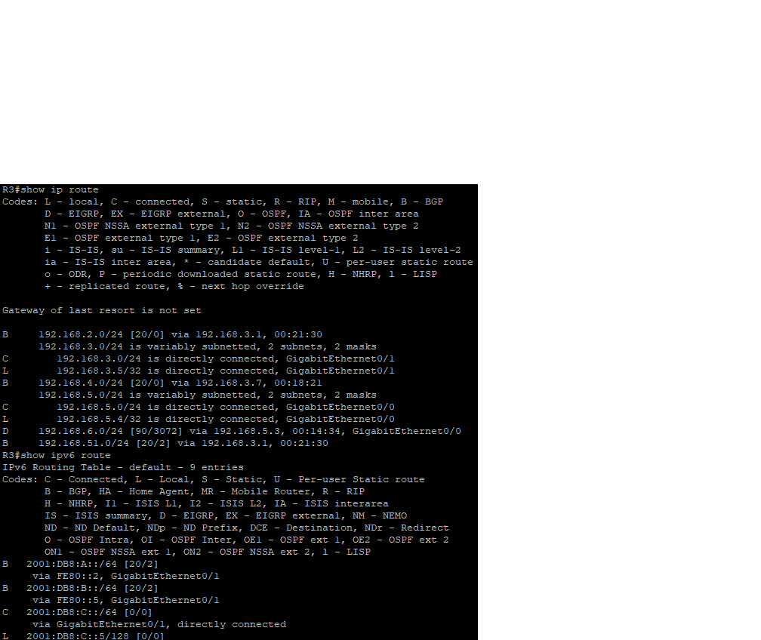----------------

Routing Table R3

----------------

----------------

Routing Table R4

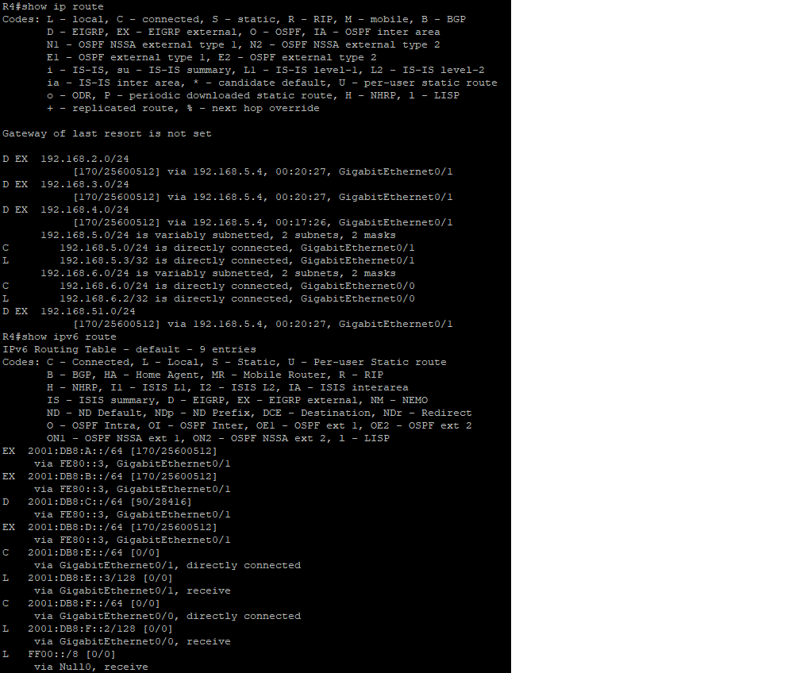----------------

----------------

Routing Table R5

----------------

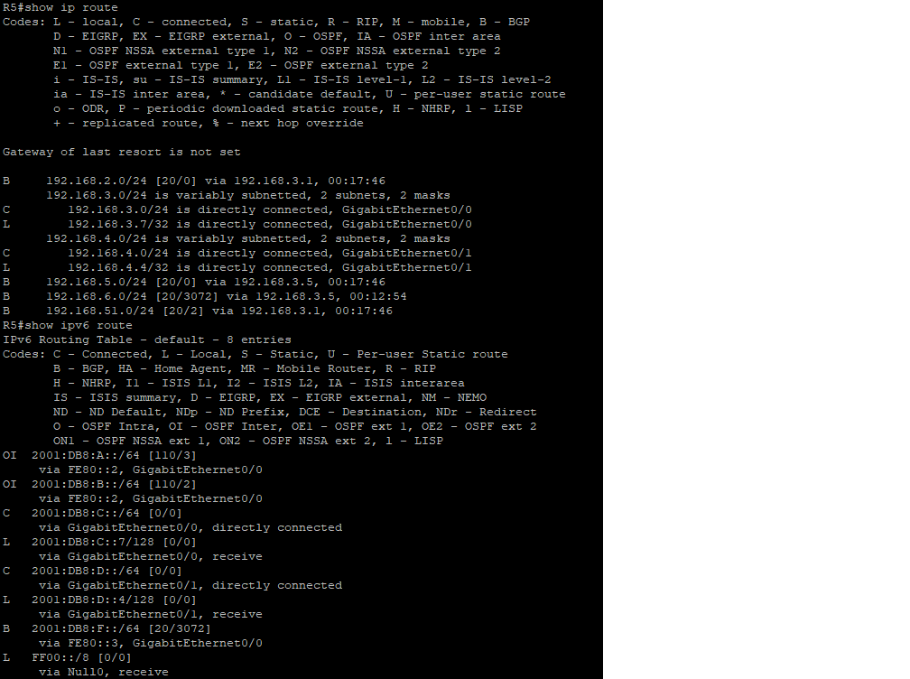

----------------

Routing Table R6

----------------

